Login

Pseudocode
START
ENTER username and password IF details are correct THEN SHOW pages for the user
ELSE
SHOW login error END IF
IF logout is clicked THEN LOG OUT
END IF END

Flowchart

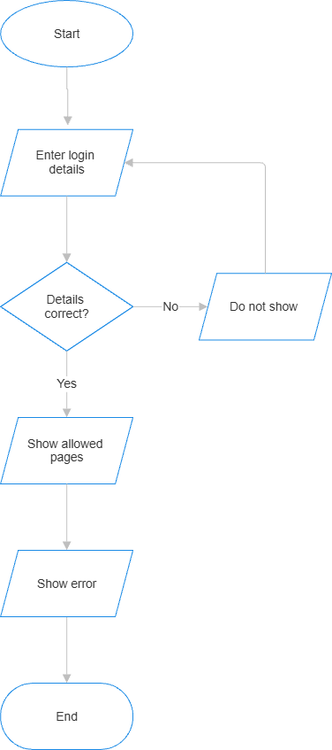
.

Worker Safety

Pseudocode
START
READ workers data SHOW worker list CHECK PPE and fatigue
IF PPE is No OR fatigue is 4 or more THEN SHOW unsafe workers
END IF END

Flowchart
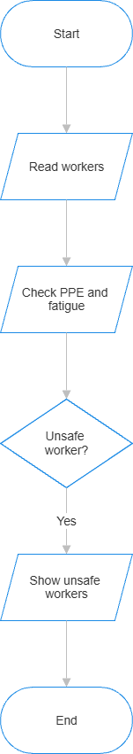

Incident Database

Pseudocode
START
READ incidents data SHOW incidents
IF Add Incident is clicked THEN ADD new incident to table
END IF
SEARCH or FILTER incidents SHOW matching incidents SHOW incident summary
END

Flowchart
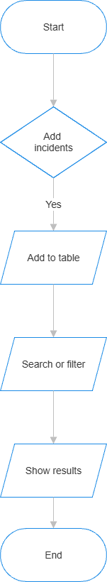

Equipment Monitoring

Pseudocode
START
READ equipment data
CHECK temperature and vibration
IF temperature > 100 OR vibration > 8 THEN STATUS = Critical
ELSE IF temperature > 80 OR vibration > 5 THEN STATUS = Warning
ELSE
STATUS = Normal END IF
SHOW status END

Flowchart
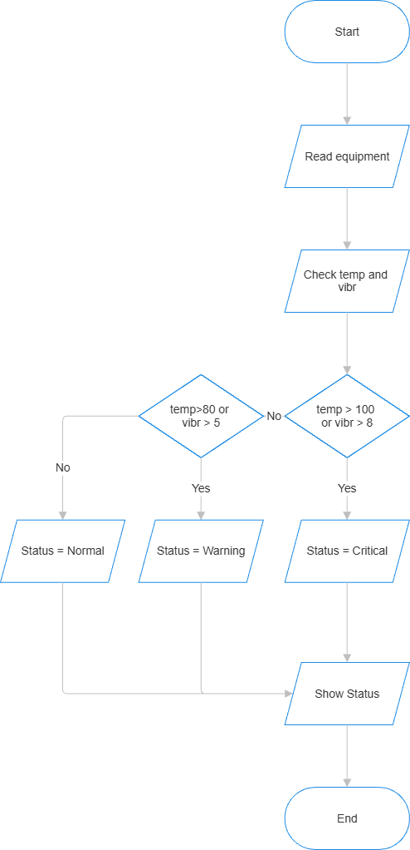

Risk Assessment

Pseudocode
START
SELECT likelihood SELECT consequence
CALCULATE score = likelihood x consequence IF score <= 4 THEN
SHOW Low
ELSE IF score <= 9 THEN
SHOW Medium
ELSE IF score <= 16 THEN
SHOW High ELSE
SHOW Critical END IF
END

Flowchart
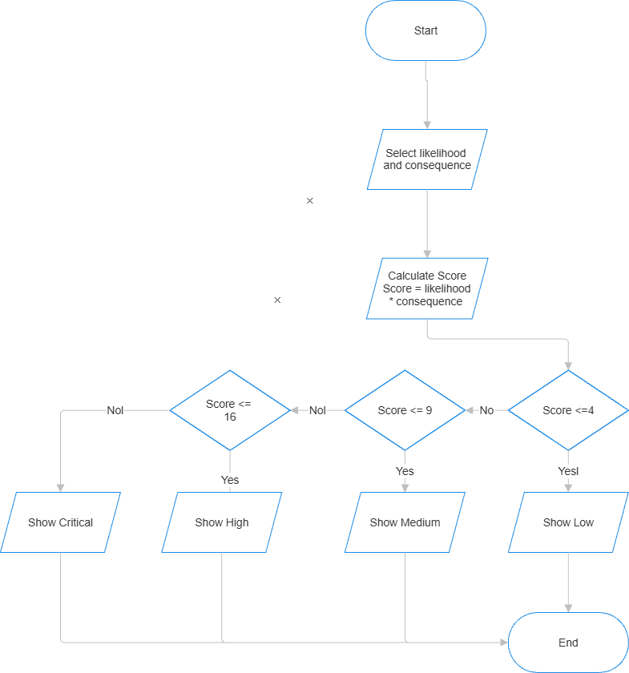

Maintenance

Pseudocode
START
READ equipment data CALCULATE availability
CHECK downtime and maintenance status IF availability < 80 THEN
SHOW warning END IF
SHOW maintenance summary END

Flowchart

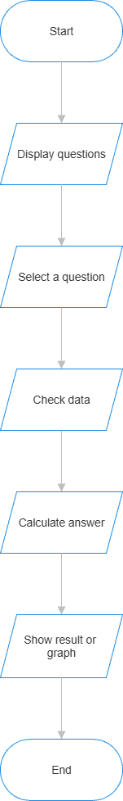

Dashboard

Pseudocode
START
READ workers, incidents and equipment COUNT workers and incidents
CALCULATE PPE compliance COUNT equipment and alerts SHOW dashboard numbers
END

Flowchart
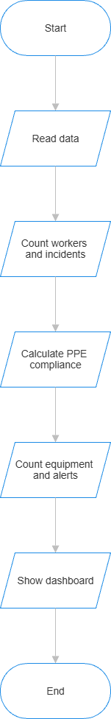
.

Interactive Analysis

Pseudocode
START
SHOW mining questions SELECT one question
CHECK which data is needed CALCULATE the answer
SHOW answer or graph END

Flowchart
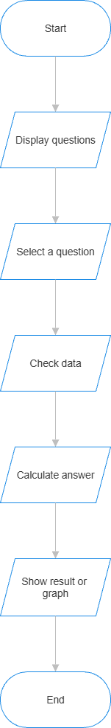
.

Reports

Pseudocode
START
READ mining data CALCULATE report numbers MAKE summary table
SHOW table
IF Download is clicked THEN DOWNLOAD CSV report
END IF END

Flowchart



